APPENDIX G: TIME BREAKDOWN OF PROJECT

TIME BREAKDOWN OF TASKS INVOLVED IN THE INVESTIGATION OF VOICE CONTROLLED WEB BROWSING FOR THE ELDERLY

Cole D. Noble

School of Electrical & Information Engineering, University of the Witwatersrand, Private Bag 3, 2050, Johannesburg, South Africa

# introduction

The following paper presents time related information pertinent to the investigation undertaken to try and improve the web browsing experience of the elderly. First, key dates pertaining to the project are given. This is followed by time breakdowns of time spent on the project for each of the team members involved in the project.

# key dates

A few dates were key to the completion of the project. The first set of dates are those dates allocated for meetings with the project supervisor, Mr Aveer Ramnath. These meetings helped keep the team accountable to the supervisor concerning progress on the project. These meetings also provided a platform for gaining a 3rd opinion on solving/avoiding problems. These meeting dates are provided below in table 1.

Table 1: Dates of meetings held with supervisor

|  |  |
| --- | --- |
| 6 September | Meeting 1 with Supervisor |
| 20 September | Meeting 2 with Supervisor |
| 25 September | Meeting 3 with Supervisor |
| 3 October | Meeting 4 with Supervisor |
| 10 October | Meeting 5 with Supervisor |
| 17 October | Meeting 6 with Supervisor |

Another set of key dates were those of project commencement, due dates for iterations, planned dates to start iterations, dates to test iterations, and finally, dates that required complete project completion. These dates are provided below in table 2. Please note some of these dates, namely those concerned with iteration completion and testing, did shift initially around as some things took longer than expected. The final dates are thus illustrated below.

Table 2: Other key dates in project

|  |  |
| --- | --- |
| 6 September | Start project |
| 3 October | 1st Iteration due |
| 4 October | Start testing Iteration 1 |
| 6 October | Start 2nd and 3rd Iteration |
| 11 October | Start testing last two iterations |
| 21 October | Staff open day |
| 24 October | General open day |
| 27 October | Report hand in |

# individual time spent by individuals

## Overview

The two team members of the project, namely, Cole Noble and Kirti Nathoo kept track of the total time spent on the project. Cole Noble used a time tracking tool, *Toggl* [1], to keep track of the time spent on the project. Kirti Nathoo kept track of her time usage manually. These time and task indicators are now given.

## Time spent by Cole Noble

The main daily events of the work done on the project are proved below in figure 1. For the first 3 weeks of the project, the time keeping tool was used rigorously to record every minute spent on the project. This, in itself, became a somewhat time consuming endeavour. For this reason, following the 25th of September, times were recorded more generally. That is, at the end of every day an honest estimate of how much time was spent actually working was recorded. This accounts for why each task duration changed from giving second indications to only giving hour indications. As can be seen from the total given in Figure 1 below, an approximate total time of 235 hours was spent on the project.

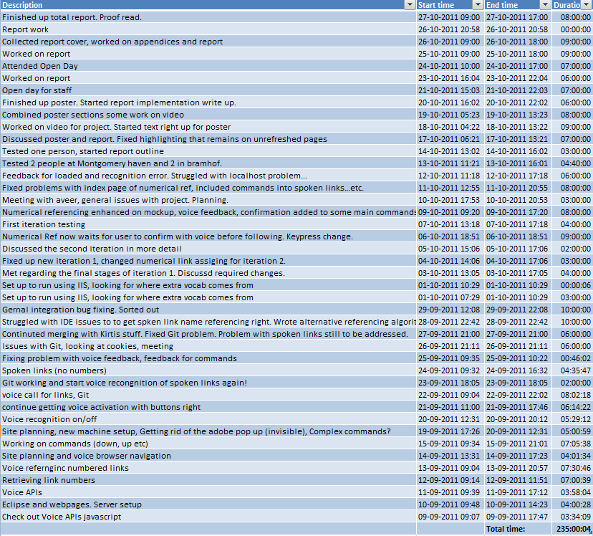

Figure 1: Time record of main events in project by Cole Noble

The results of gigure 1 were plotted (by *Toggl*) to give graphical indication of how time usage was spread out for the duration of the project. This indication is given in figure 2 below. From this graph it can be seen that the time spent working on weekends was minimal and that time expenditure became more consistent and elevated during the later phases of the project.

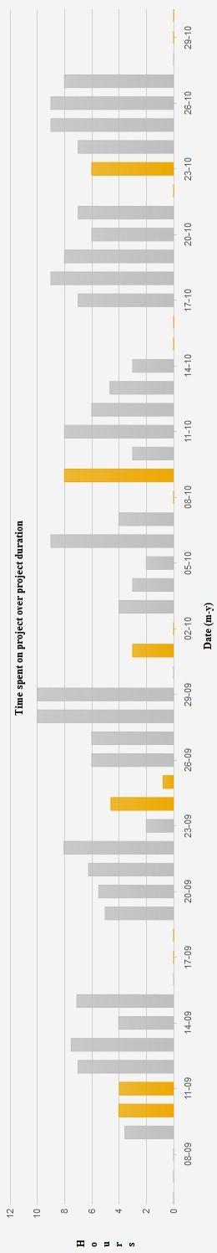

Figure 2: Total hours spent on project by Cole Noble

## Time spent by Kirti Nathoo

The daily tasks that were completed during the project implementation are shown in figure 3. The first two weeks were used to become familiar with JavaScript and HTML. Thereafter the first substantial web application was developed and minor changes were continuously appended. After which the work load increased significantly. However most time spent working on the project was during the day and minimal work was accomplished over weekends. The times indicated include breaks. A total of 220 hours was spent on the complete project. However the application was completed within six weeks and the remaining weeks were used to design the poster and to begin formulating the report.

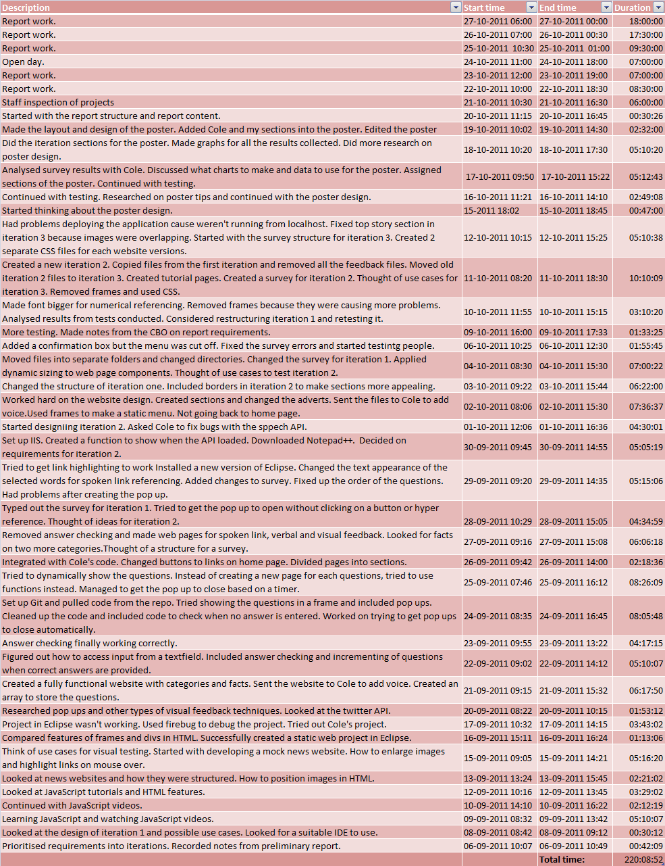

Figure 3. Time record of main events in project: By Kirti Nathoo

# Conclusion

This paper has made mention of a few of the key dates involved in an investigation that was undertaken to improve the usability of the internet for the elderly. Key dates regarding meetings, software iterations and project testing were chiefly provided. Following this the time spent on the project by the team members, Cole Noble and Kirti Nathoo, was given. Cole Noble spent a total of 235 hours on the project and Kirti Nathoo spent a total of 220 hours on the project.

# Bibliography

1. **Toggl.** Tasks. *Toggl.* [Online] 2011. [Cited: 26 October 2011.] https://www.toggl.com/tasks.